* The system does not accept valid strong passwords with

special characters and mixed case.

* After sign-up, the user is not redirected to the login page and

remains on the sign-up confirmation screen.

* The user can complete sign-up without checking the terms and conditions checkbox, bypassing the required validation.
* The system accepts weak passwords that do not meet the specified
* complexity requirements (e.g., missing numbers or special characters).
* The sign-up form allows users to sign up without completing the CAPTCHA, bypassing this security check.

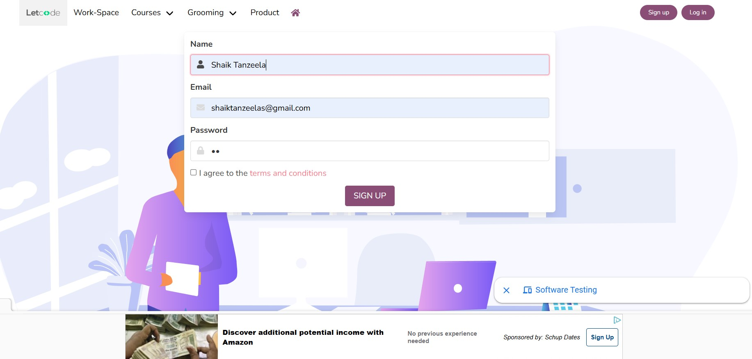

* After clicking the "Sign out" button, the user remains logged

in and can still access protected pages.

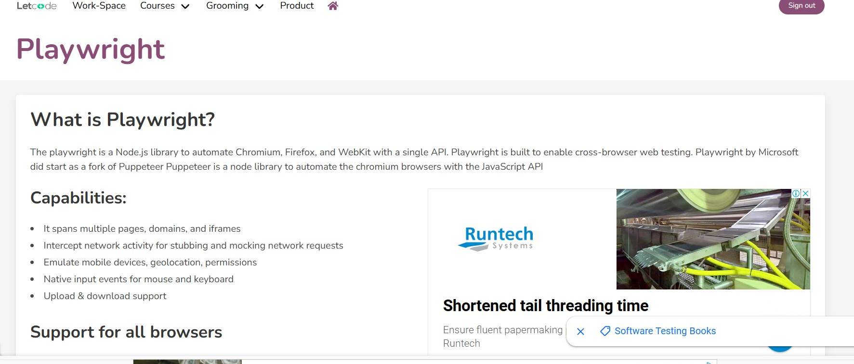

* The user is not able to click on the "UI & Design, features Catogeries

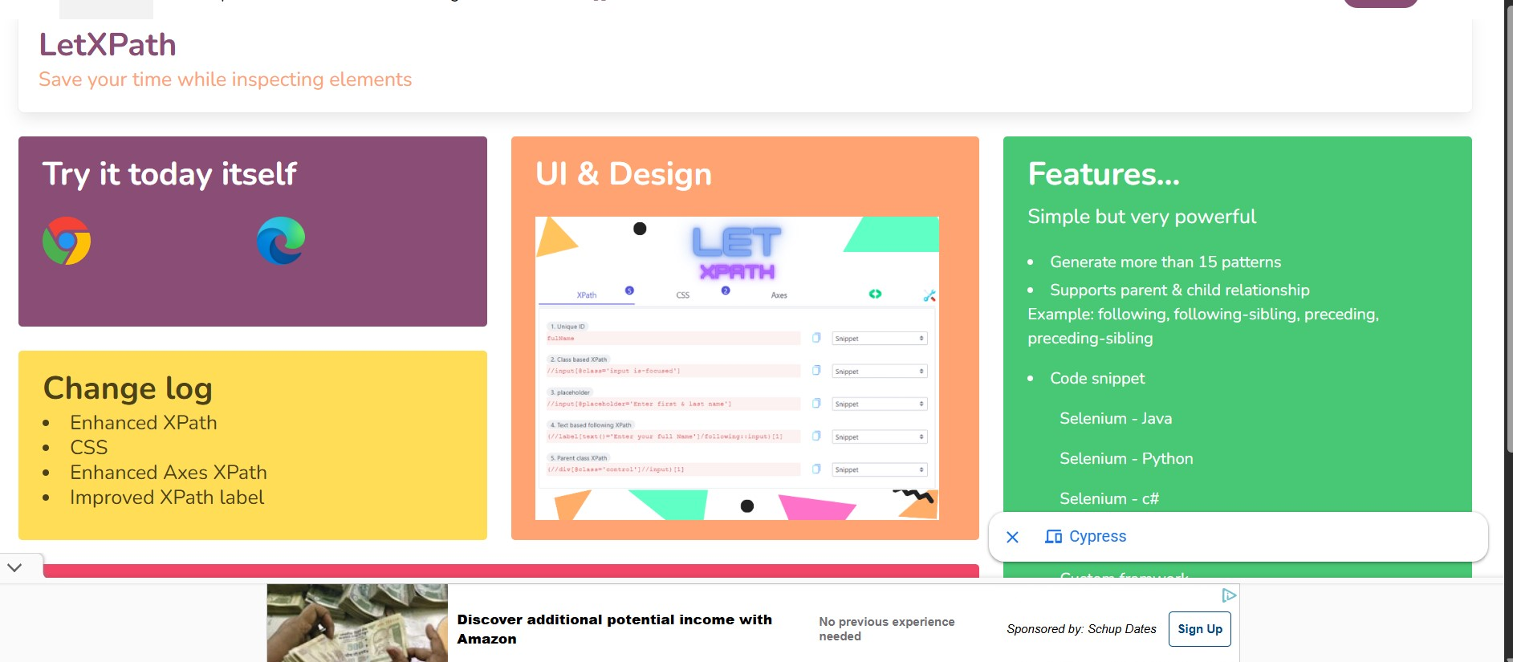

* The user is not Redirected to the login page after the Sign out
* User is able to access the protected pages after sign out
* The user is not able to easily understand the forms

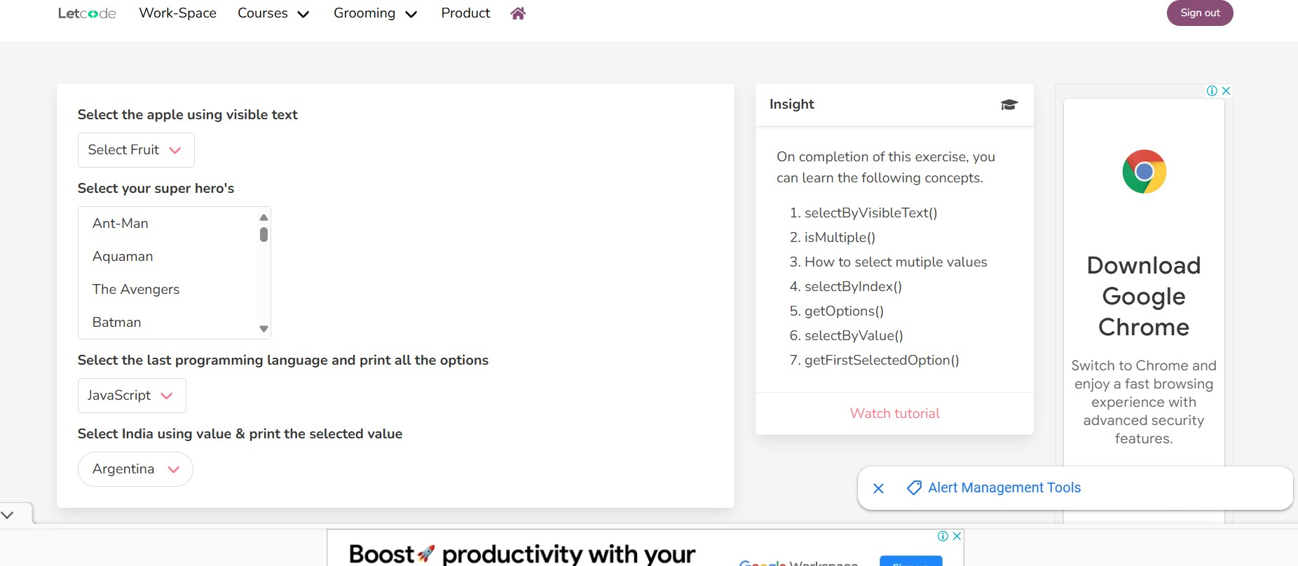

* The cursor is not automatically focus on the username field.
* The form does not automatically focus on the first input field,

requiring the user to manually click to begin filling out the form.

* The password field does not include a "show/hide" toggle, forcing users to re-enter passwords multiple times if errors occur.
* There is no inline message is display for

the password

* Error messages appear at the top of the form, not next to the field causing the error, making it difficult for users to identify the issue.

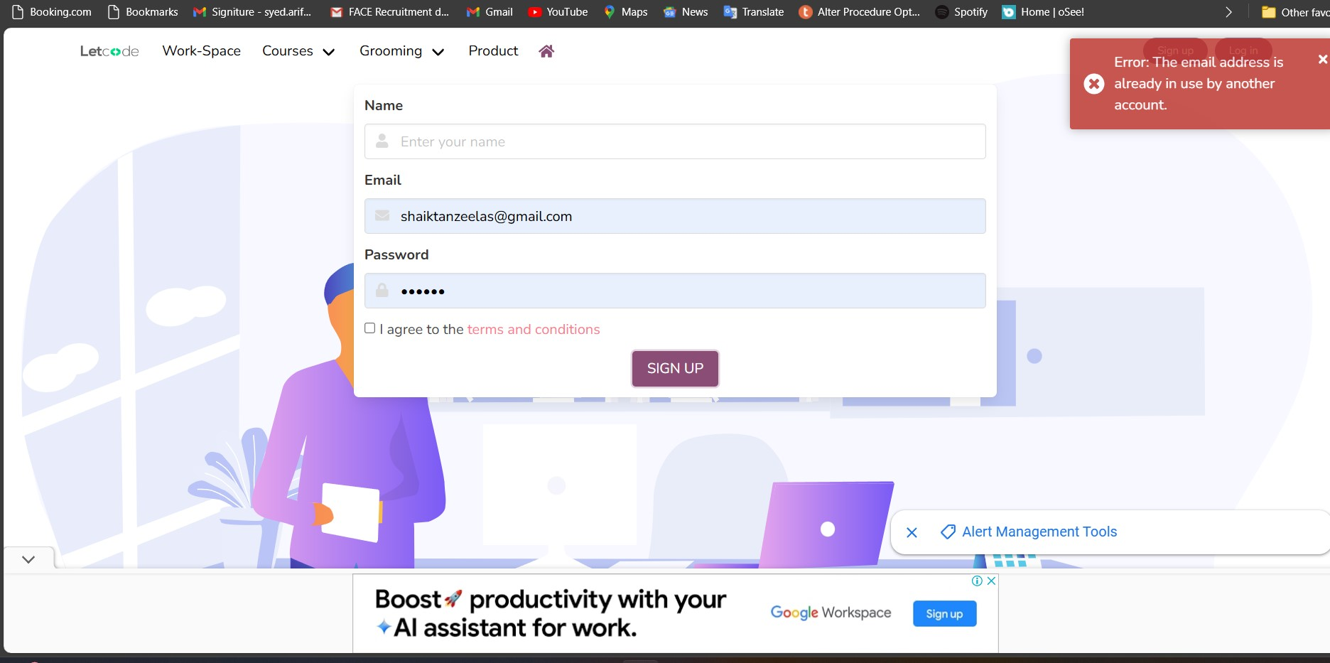

* User is not able to see the sign up button on homepage in Mobiles

